20 Probability

20.1 The Percolation Model

Question 1:

1. Why θ is non-decreasing in $p$?

According to the notes at the end of the project, it suggests that we may label each edge with a pseudo-random number which is uniformly distributed from 0 to 1 and use the same realization for all values of $p$ simultaneously. We assume an edge is open when the assigned number of the edge is $≤p$.

Let $μ\left(p_{1}\right)and μ\left(p_{2}\right)$ be the set of edges that are open under the $p=p_{1}$ and $p=p_{2}$,  
Under the same realization, we can deduce that $\left|μ\left(p_{1}\right)\right|≤\left|μ\left(p_{2}\right)\right|$ if $p_{1}≤p_{2} (*)$  
As there are more edges available for $p=p_{2}$ than for $p=p_{1}$ (for which $μ\left(p_{1}\right)⊆μ\left(p_{2}\right)$), we can conclude that $\left\{y:y are accessible nodes as p=p_{1}\right\}⊆\left\{y:y are accessible nodes as p=p_{2}\right\}$. Therefore, $θ\left(p_{1}\right)≤θ\left(p_{2}\right)$ if $p_{1}≤p_{2}$.

1. Show $θ_{n}\left(p\right)$ is decreasing in $n$.

For $θ_{n}\left(p\right)=P_{p}(\left|C_{n}\right|≠∅)$, we can see it is dependent on $θ_{n-1}\left(p\right)=P_{p}(|C_{n-1}|≠∅)$ as we know if $\left|C_{n-1}\right|=∅$, $\left|C_{n}\right|=∅$ must be true as well.

Therefore,

$$θ_{n}\left(p\right)=P_{p}\left(\left|C_{n}\right|≠∅\right) \\ =P_{p}\left(\left|C_{n}\right|≠∅ \bigcap{\left|C_{n-1}\right|}≠∅\right) \\ =P_{p}\left(\left|C_{n}\right|≠∅ \right| |C_{n-1}|≠∅ )P_{p}(|C_{n-1}|≠∅ ) \\ ≤P_{p}\left(\left|C_{n-1}\right|≠∅ \right) \\ ≤θ_{n-1}\left(p\right)$$ ■

1. Give an estimate for the likely size of the error ${\hat{θ}}_{m,n}\left(p\right)-θ_{n}(p)$.

Question 2:

Regarding to the computational time of the program, I have chosen m=1000 and n=800 for my program [percolationQ2_mod.m] to plot ${\hat{θ}}_{m,n}\left(p\right)$ against $p$ for $p∈[ 0.5 ,0.75 ]$, which takes around 67 seconds to run for $p_{c}≈0.62$, which is close to the our believed result, $0.644$.

Graph 1: Relationship between

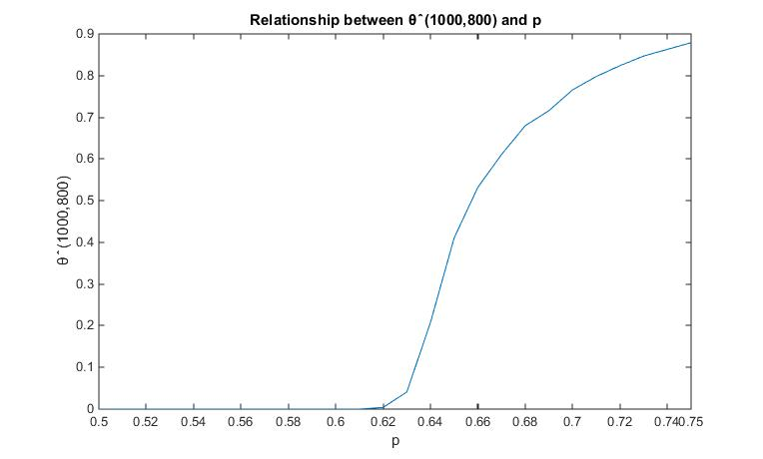

In my program [percolationQ2_mod.m], I have first generate 2 random matrix $A_{ij} and B_{ij}$ of size $\left(n*n\right)$ representing the values on the vertical and horizontal edges from node $\left(i-1,j-1\right)$. It runs at $O\left(n^{2}\right)$. Secondly, I followed the suggested algorithm from the notes and calculate $Z\left(x\right)$ for all nodes $x$ on the grid which involves 3 comparison operations per node which is running at $O\left(n^{2}\right)$ as well. Thirdly, I check for any $Z\left(x\right)≤p$ for $x∈Q_{n}$ and for all $p$ in the given range and this action works in $O\left(n\right)$. And lastly, we repeat the above for $m$ different realizations which means the complexity of the program in total will be $O\left(m\left(n^{2}+n\right)\right)≈O\left(mn^{2}\right).$ We can deduce that the computational time for the program is also in $O\left(mn^{2}\right).$

Therefore, I have chosen a smaller value for $n$ compared with $m$ at the start of the question.

As it is more likely for $\left|C_{n}\right|=∅$ when $n→∞$ for p fixed, we expect $p_{c}$ increases and getting closer to 0.644 as n increases and the graph of $θ\left(p\right)$ shifts to the right compared with the graph we have above.

Graph 2: plotting

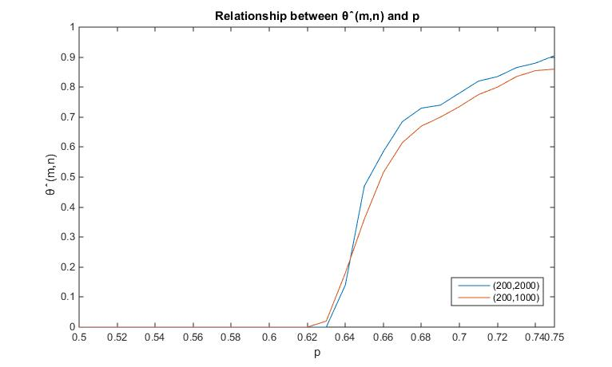

Comparing two graphs with ${\hat{θ}}_{200,2000} and {\hat{θ}}_{200,1000}$ in Graph 2, we can see $p_{c}$ shifts from 0.62 to 0.63, which is closer to the true value, 0.644 as n increases. In addition, we can see the graph is tending to a Heaviside function as n increases. I believe as n increases, the graph will tend to $H(p-0.644)$ where H is a Heaviside function.

Question 3:

From graph 4, we can see ${\hat{p}}_{c}$ increases and tends to reach the true value $p_{c}=0.644$ as $n$ increases and $m$ (large) fixed. This is because, similar reason in Question 2, it is more likely for $C_{n}=∅ as n increases$. Therefore, the value for ${\hat{p}}_{c}$ increases as n increases. On the other hand, as ${\hat{θ}}_{m,n}(p)$ is a decreasing function in n and increasing function in p, for getting the ${p_{s}=sup⁡\{p: \hat{θ}}_{m,n}\left(p\right)=0\}$ for fixed m and increasing n, we should expect $p_{s}$ increases and it will always be $p_{s}(n)≤p_{c}$ and $p_{s}\left(n\right)→p_{c}$ for $n→∞$.

For fixed n, as m increases, we expect ${\hat{p}}_{c}$ fluctuate and converges to a limit ${\hat{p}}_{c}(n)$ where ${\hat{p}}_{c}\left(n\right)$ is a constant and ${\hat{p}}_{c}\left(n\right)=\sup\left\{p: θ_{n}\left(p\right)=0\right\}≤p_{c}.$ (‘Less than or equal to $p_{c}'$ because of squared statement above.).   
For showing $p_{s}=\sup\left\{p: {\hat{θ}}_{m,n}\left(p\right)=0\right\}→{\hat{p}}_{c}\left(n\right)=\sup\left\{p: θ_{n}\left(p\right)=0\right\} as m→∞$, we may use the statement from the law of large numbers where the sample average tends to the expected value as $m→∞$.  
We can confirm our prediction with the Graph 3 as we can see a fluctuation between 0.5 to 0.57 and converging to the range of [0.51, 0.54].

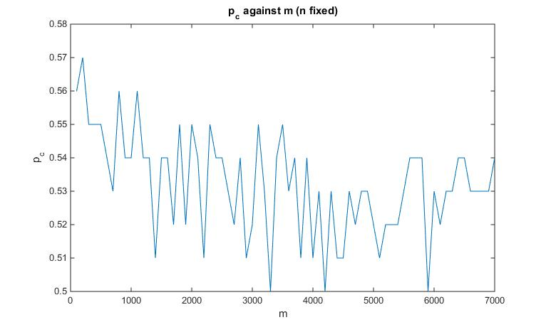  
 Graph 3: plotting $p_{c} against m with n fixed$

Graph 4: plotting

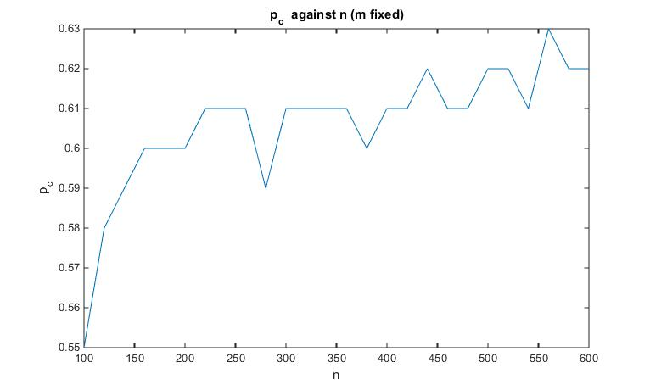

Question 4:

To estimate $γ$, I have written a program which gives me the $P_{p}(C_{n}≠∅)$ out of the m realization with a given p through running the program [percolationQ2_mod.m] and calculate $γ$ with the calculated $P_{p}(C_{n}≠∅)$ and input n.

It is tricky to pick the suitable value for m and n as it always turns out to be undefined if I have picked a relatively large n due to $P_{p}\left(C_{n}≠∅\right)=0$ if n is large and p is in the range [0.3-0.6] and $log⁡(0)$ does not give us any useful information at all. Therefore, I need to pick a relative small n for this estimation.

On the other hand, as there is more chance for me to get at least a realization with $\left(C_{n}≠∅\right)$ if I picked a large m, I expect to pick a large m in respect to n for the estimation.

As $P_{p}\left(C_{n}≠∅\right)$ an increasing function in p and decreasing function in n, I expect that we can increase our value of n as we increase in p. By trial and error, I obtained the largest n which works